Hardware And Components

Assignment Day-1

Task-1: Draw a labeled diagram of a desktop PC, clearly marking the motherboard, CPU, RAM, GPU, and both HDD and SSD storage components.
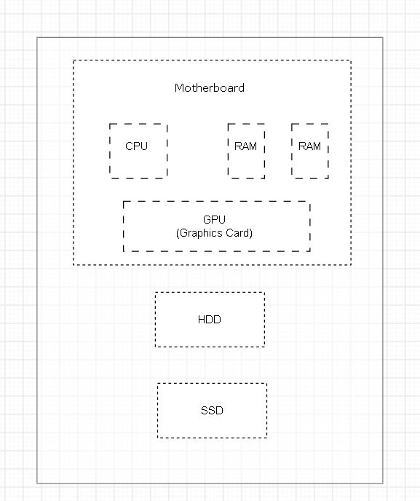

Main Components of a Desktop PC
- Motherboard: Main circuit board that connects all the components.
- CPU: Acts as the brain of the computer and processes instructions.
- RAM: Temporary memory used to store data while the computer is running.
- GPU: Processes graphics, images, and videos.
- HDD: Provides large-capacity storage and is generally slower than an SSD.
- SSD: Provides faster storage and helps the computer boot and load applications quickly.
Task-2: Create a comparison table showing the main differences between HDD and SSD storage in terms of speed, durability, and typical use cases.<br><br><em><strong>Hint:</strong> Think about which one is faster, which is more shock-resistant, and where you would usually find each type (laptop, gaming PC, etc.).</em>

Feature | HDD | SSD
Technology | Uses spinning magnetic disks | Uses flash memory
Speed | Slower | Faster
Durability | Less durable due to moving parts | More durable; no moving parts
Shock Resistance | More sensitive to shocks | More resistant to shocks
Storage | Large storage at lower cost | Usually costs more for the same capacity
Power Consumption | Higher | Lower
Typical Use | Desktop PCs, backups & bulk storage | Laptops, gaming PCs & fast storage
Noise | Produces some operating noise | Silent

Task-3: Write a short explanation (2-3 sentences each) describing the role of the CPU, RAM, and GPU in running a game like PUBG or Free Fire on a PC.

Role of CPU, RAM & GPU in Gaming
CPU (Central Processing Unit)
- The CPU handles the main instructions and calculations of the game.
- It manages things like player movement, game logic, and communication between different components.
RAM (Random Access Memory)
- RAM temporarily stores the game data that is being used while playing.
- More RAM helps the game run smoothly and reduces lag when other applications are running in the background.
GPU (Graphics Processing Unit)
- The GPU renders the game's graphics, including characters, maps, textures, and effects.
- A powerful GPU provides better visual quality and smoother gameplay with higher FPS.
Task-4: Imagine you want to upgrade your PC to run the latest version of FIFA smoothly. List which hardware components you would consider upgrading and explain why for each.
If I wanted to upgrade my PC to run the latest version of FIFA smoothly, I would consider upgrading the following components:
- GPU (Graphics Card): I would upgrade the GPU because it handles the game’s graphics and helps provide smooth gameplay with better FPS.
- CPU (Processor): A better CPU would help process game instructions, player movements, and other game-related tasks faster.
- RAM: Increasing the RAM would help the game run smoothly and reduce lag, especially when other applications are running.
- SSD: I would install an SSD to reduce loading times and make the game and overall PC feel faster.
- Cooling System: Better cooling would help prevent the PC from overheating during long gaming sessions.
- Power Supply: If I install powerful components, I would also consider a suitable power supply to provide enough power to the upgraded hardware.

